Day 7 - 104608492 - Shirisha Perapagu

Java basics

Task001:

Wap to display greetings

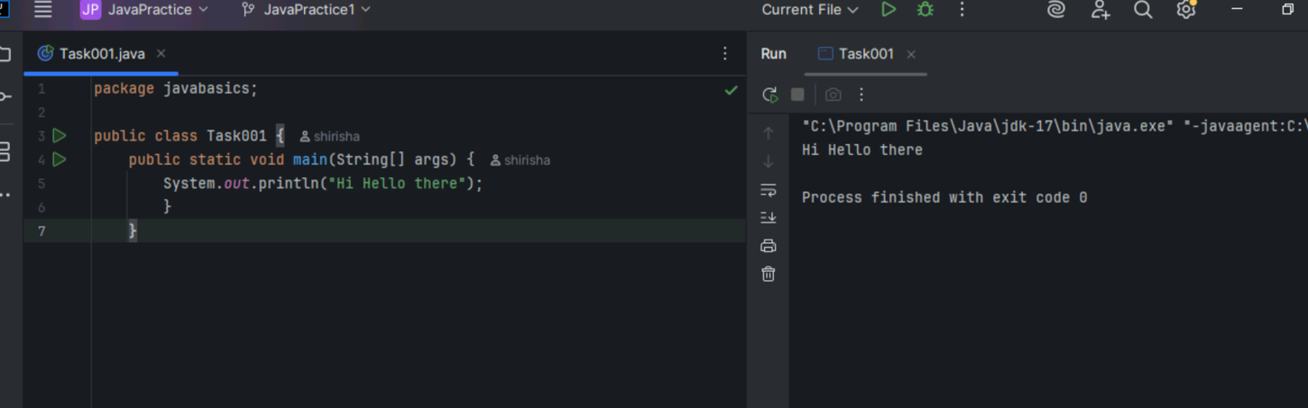

Task002:

Wap to create a add method and call the method 3 times

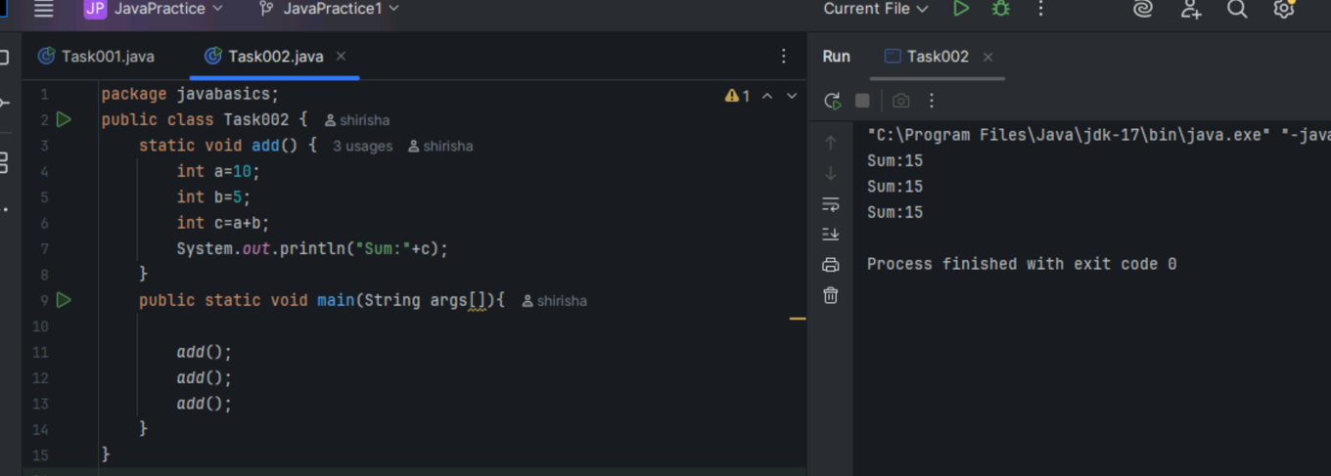

Task003

Write a Program in Java to Add two Numbers.

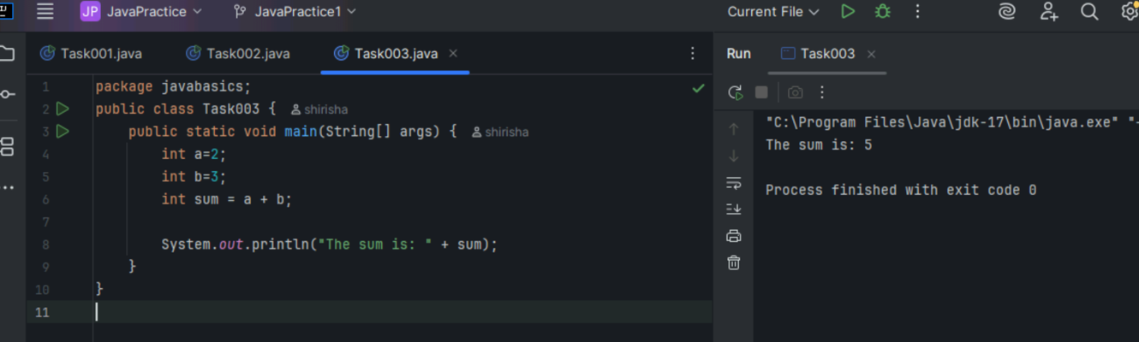

Task004

Write a Program to Swap Two Numbers

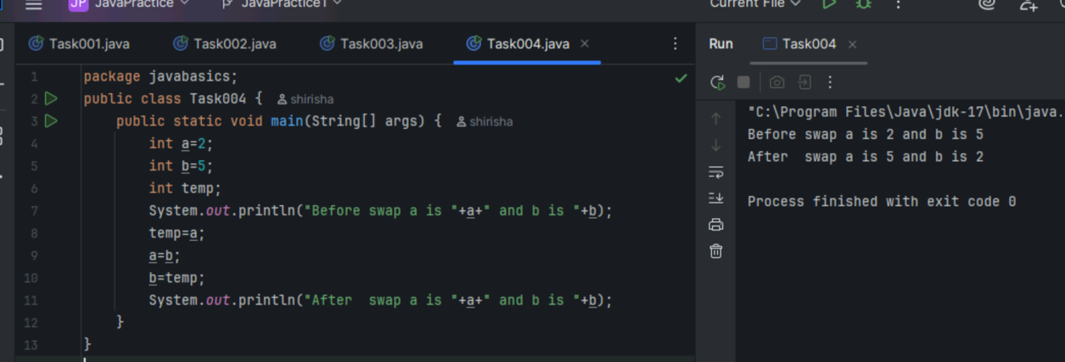

Task005

Create a code in which you have 4 methods add, subtract, multiply and divide (return type int) with a main method to call all the other methods

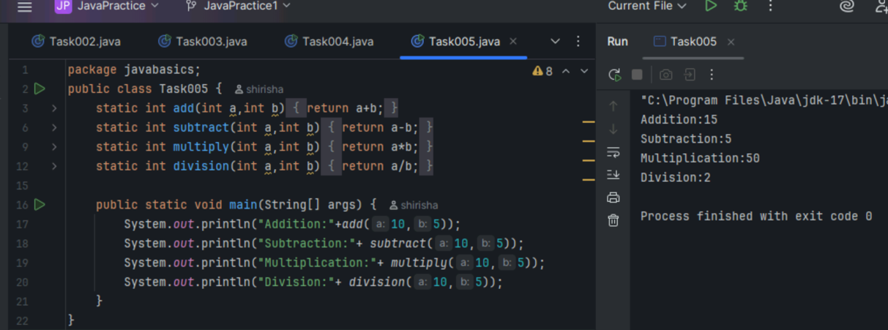

Task006

Write a program to check if a is greater or b.. Use ternary op

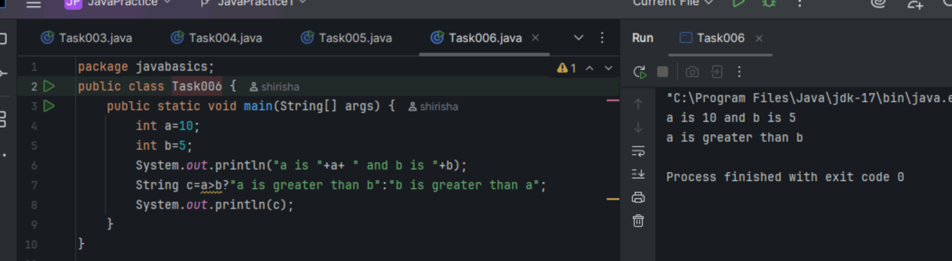

Task007

Write a program to take input from the user and display it to the user

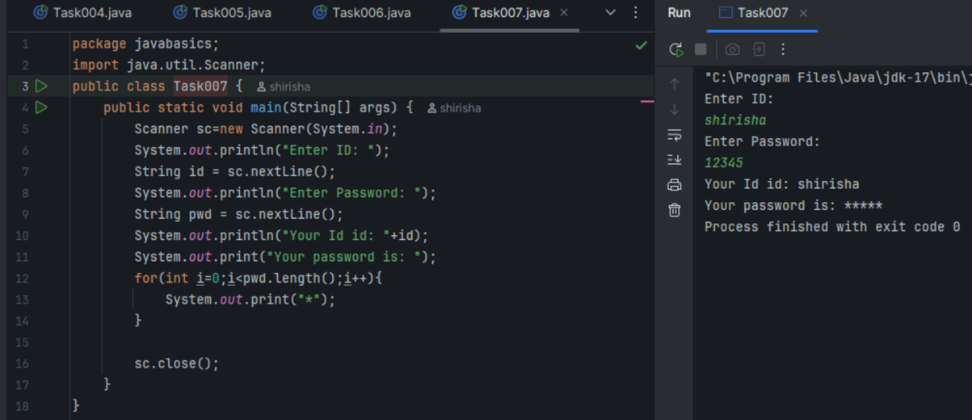

Task008

Write a program to create a class named Customer

Call the customer class in Task008 class using an object.

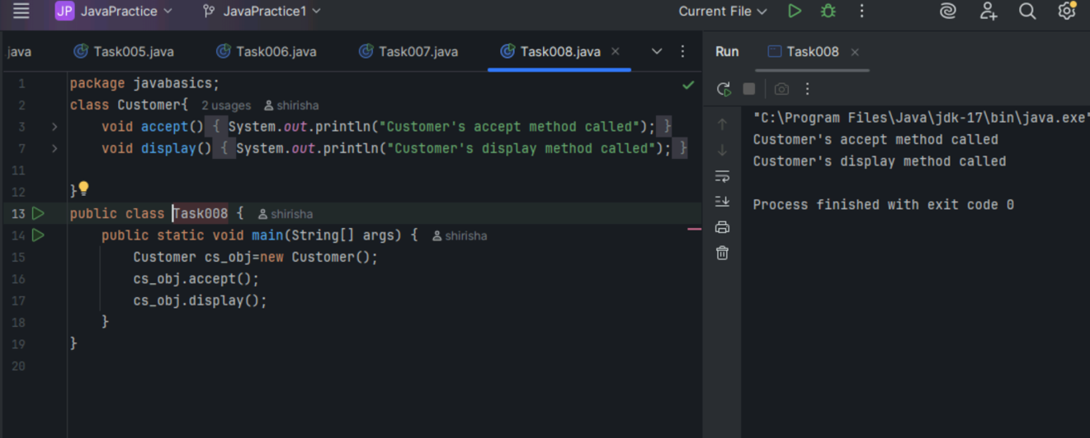

Task009

Wap to check the greater of 2 numbers

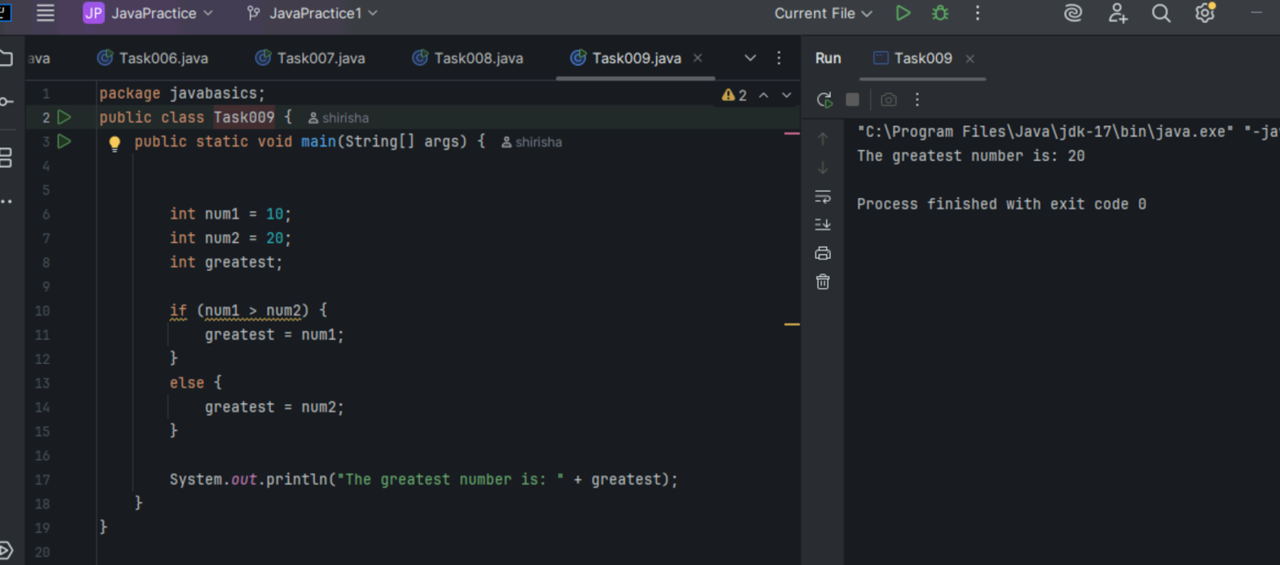

Task 010

Wap to check greater of 3 numbers

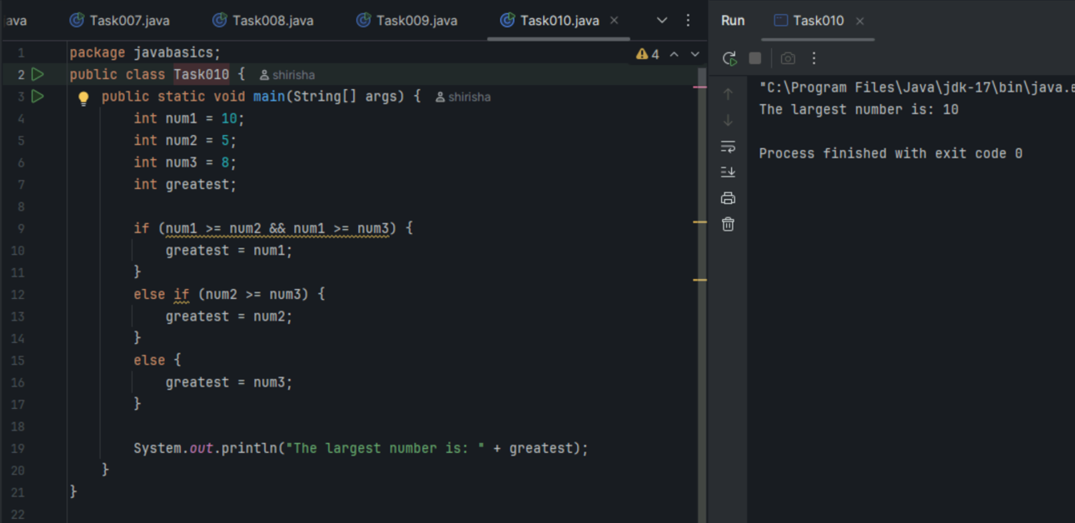

Task11:

Wap to check for week days

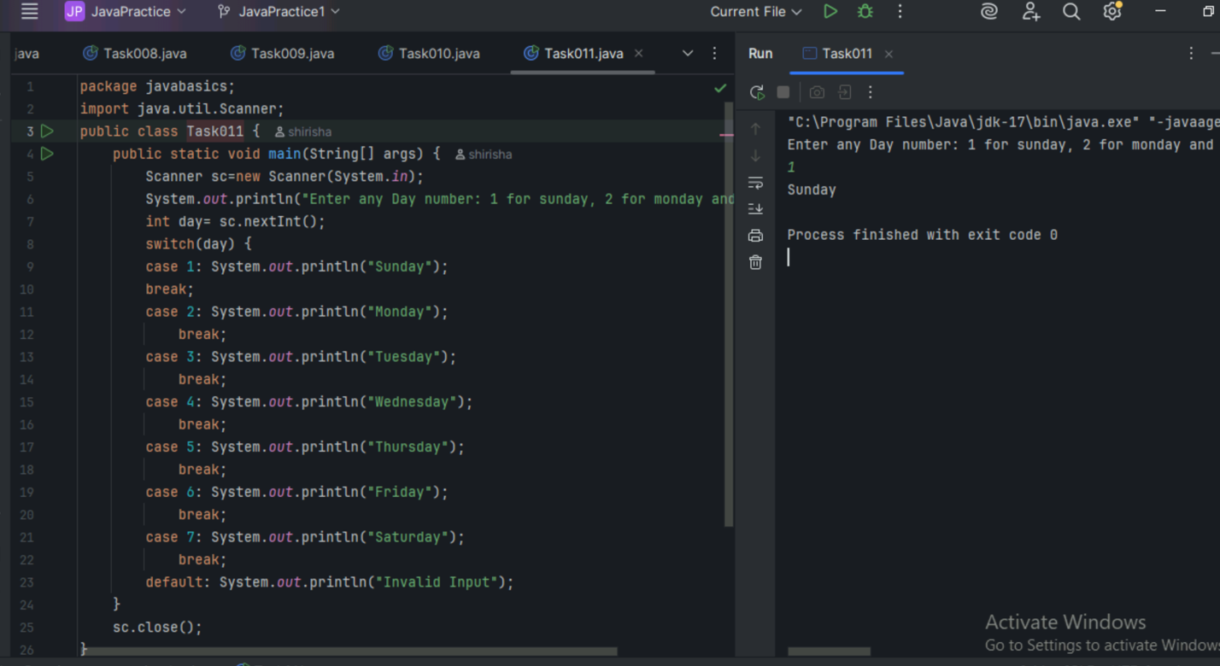

Task 012

Wap to check login id and password validation

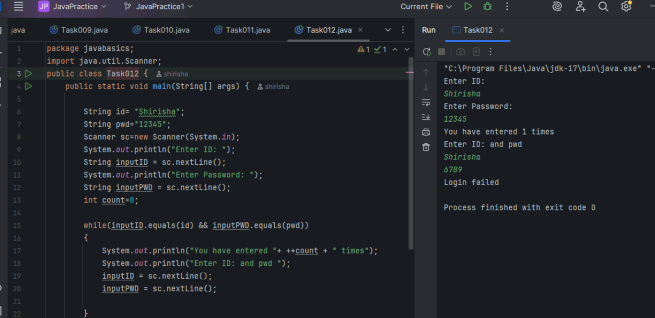

Task 13:

Wap to display numbers from 10 to 1 .. skip 7 and 5.

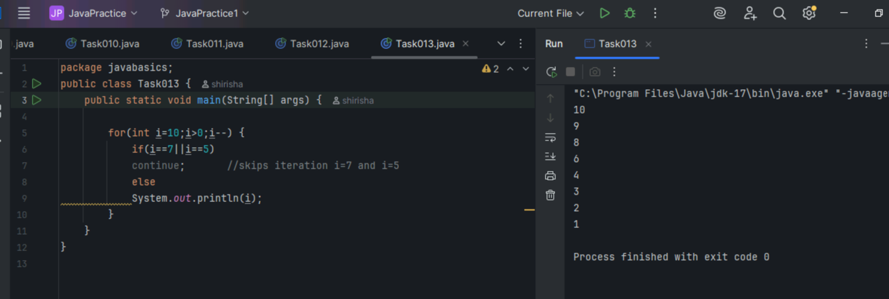

Task 014:

Character Array and String Array

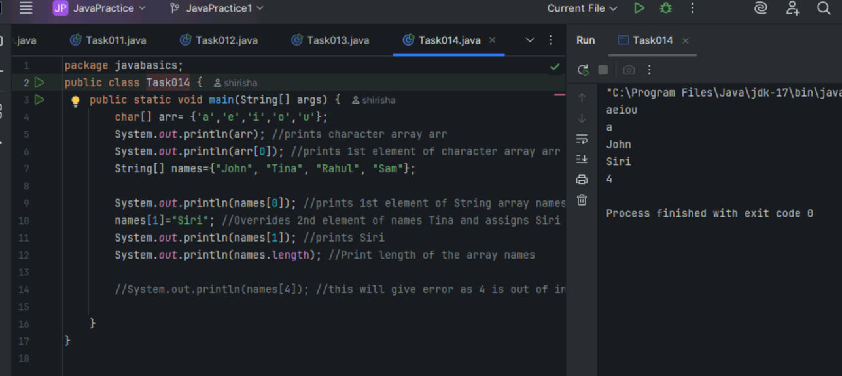

Task 015: Strings

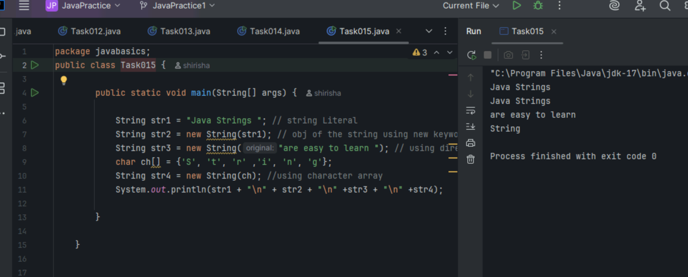

Task 016 : Enums or Enumerations

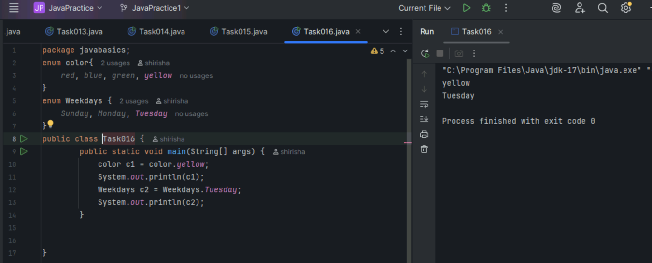

Task 017 : In the below code, what is the reason for the error in Task017?

public class Person {

   private String name;

// Getter

   public String getName() {

     return name;

   }

   // Setter

   public void setName(String newName) {

     this.name = newName;

   }

}

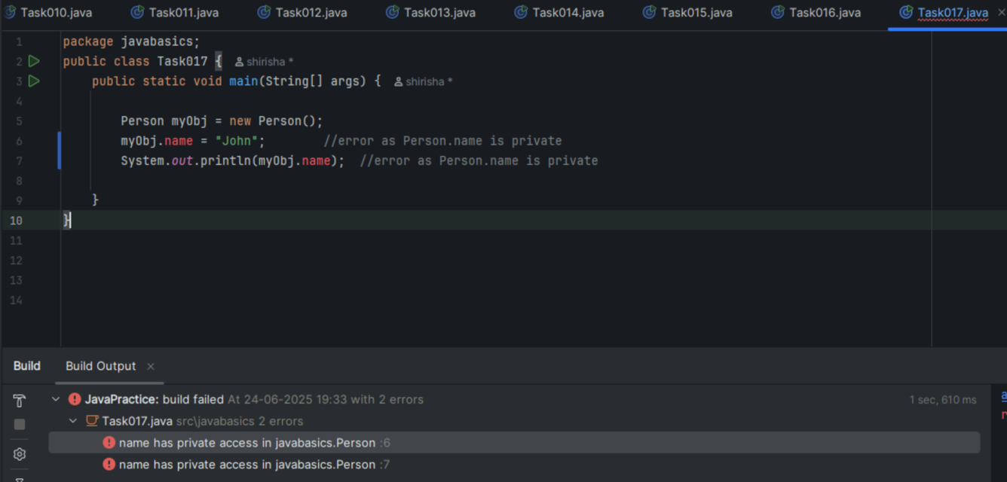

Person class’s data member name is private hence cant be accessed directly.

Task 018:

what is the output of the above code

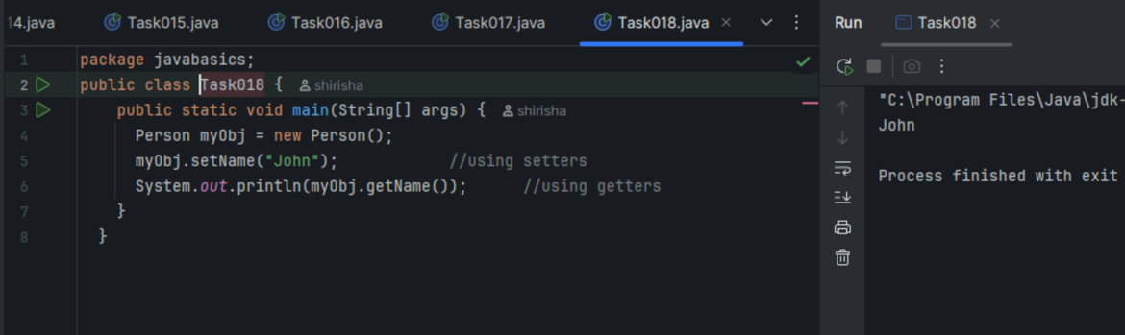

Task 019

Enums    :

//Attaching Multiple values

public enum Element {

    H("Hydrogen", 1, 1.008f),

    HE("Helium", 2, 4.0026f),

    // ...

    NE("Neon", 10, 20.180f);

    private static final Map<String, Element> BY_LABEL = new HashMap<>();

    private static final Map<Integer, Element> BY_ATOMIC_NUMBER = new HashMap<>();

    private static final Map<Float, Element> BY_ATOMIC_WEIGHT = new HashMap<>();

    static {

        for (Element e : values()) {    //for each loop

            BY_LABEL.put(e.label, e);

            BY_ATOMIC_NUMBER.put(e.atomicNumber, e);

            BY_ATOMIC_WEIGHT.put(e.atomicWeight, e);

        }

    }

    public final String label;

    public final int atomicNumber;

    public final float atomicWeight;

    private Element(String label, int atomicNumber, float atomicWeight) {

        this.label = label;

        this.atomicNumber = atomicNumber;

        this.atomicWeight = atomicWeight;

    }

    public static Element valueOfLabel(String label) {

        return BY_LABEL.get(label);

    }

    public static Element valueOfAtomicNumber(int number) {

        return BY_ATOMIC_NUMBER.get(number);

    }

    public static Element valueOfAtomicWeight(float weight) {

        return BY_ATOMIC_WEIGHT.get(weight);

    }

}

Wap to display the content of the above enum in this program.. (main  needs to be added)

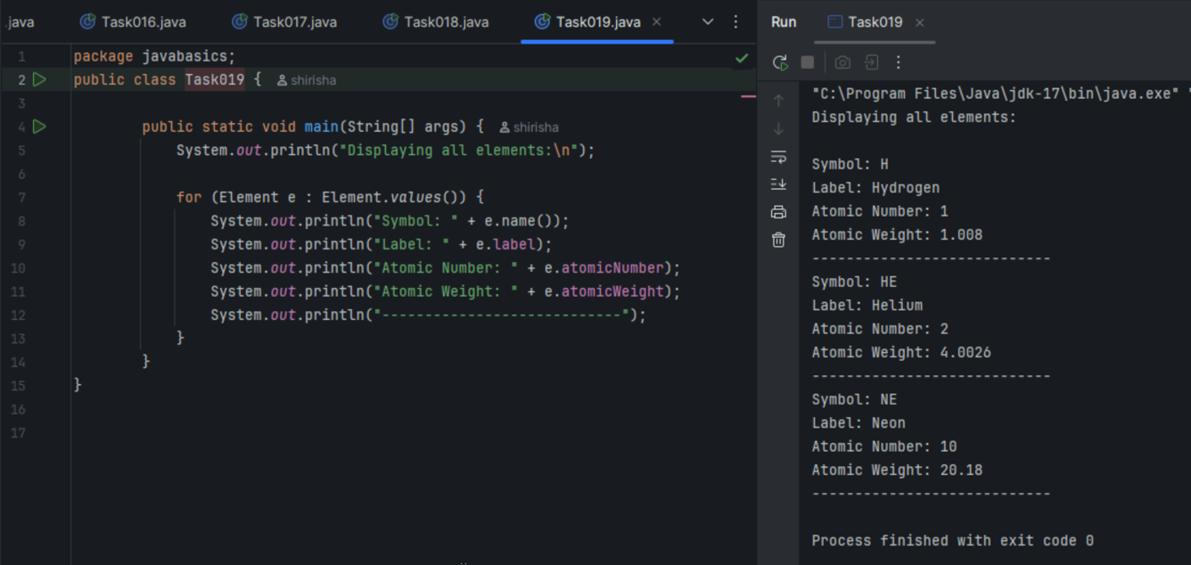

Task 020: Create an array of your name

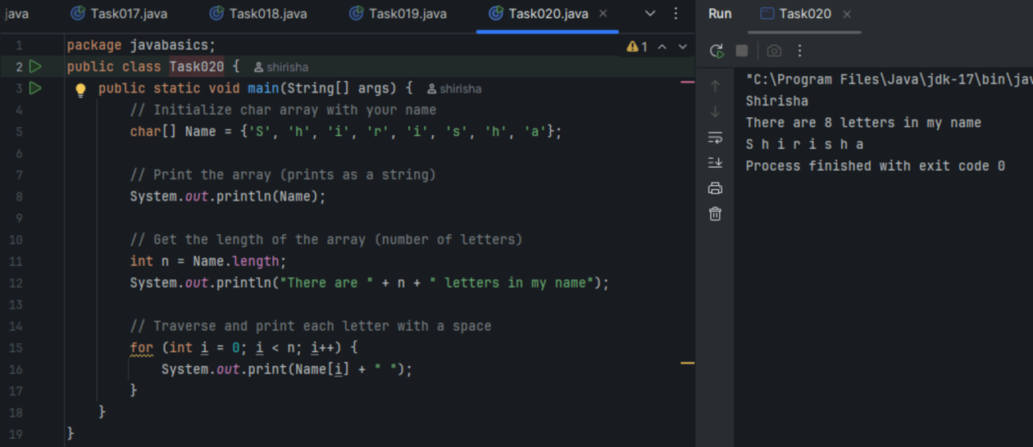

What is Shallow Copy and Deep Copy?

Shallow Copy – inner objects are shared

It copies the outer object and not the objects inside it. Here both the original and the copy share those inner objects.

Deep Copy – inner objects are cloned or newly created.

It makes a copy of everything including the inner objects. Here the original and copy are totally different and independent.